Pinner Bowls Magazine

Issue 36– July 2021

Gardening Special Edition

=====================================================================


Grass
Cuttings

As you are probably aware, Harrow Council no longer look after our green and surrounding grounds. Instead, along with several other bowls clubs, we use a commercial firm called Turf Care. They do a splendid job on the green itself, but unfortunately, they do not cut the surrounding grass nor the hedges. These remain our responsibility.

We are also responsible for disposing of the cuttings for the main green, all of the surrounds and the hedges. Typically, this involves disposing of around 20 sacks of clippings per week; although some weeks, it is a lot more.

The bulk of the work has fallen to just a few volunteers, but it is becoming increasing difficult and so it is proposed to hire a local contractor to remove the bags periodically. Naturally we have to pay. Each load of twenty bags will cost in the order of £100; or £5 the sack!

Here is where our members can help. Please, whenever you can, just take a sack or two home with you and put in your home brown wheelie bin. Each pair of bags will save the club £10.
ALL BAGS MUST GO!
Please take a bag or two of clippings as you go.
Grateful thanks from the Committee and Green keeper

The Hedges and Edges

Another major job is the hedges, which need cutting back at least 3 times a year. Our Bob S has identified a contractor who will do this, but at around £600 a bash; at least £1,200 a year; perhaps £1,800. And it is still down to us to dispose of the clipping. Yet more £5 sacks!

The edges, that is all the grass, plants and weeds that are not a part of the main green also need regular attention.

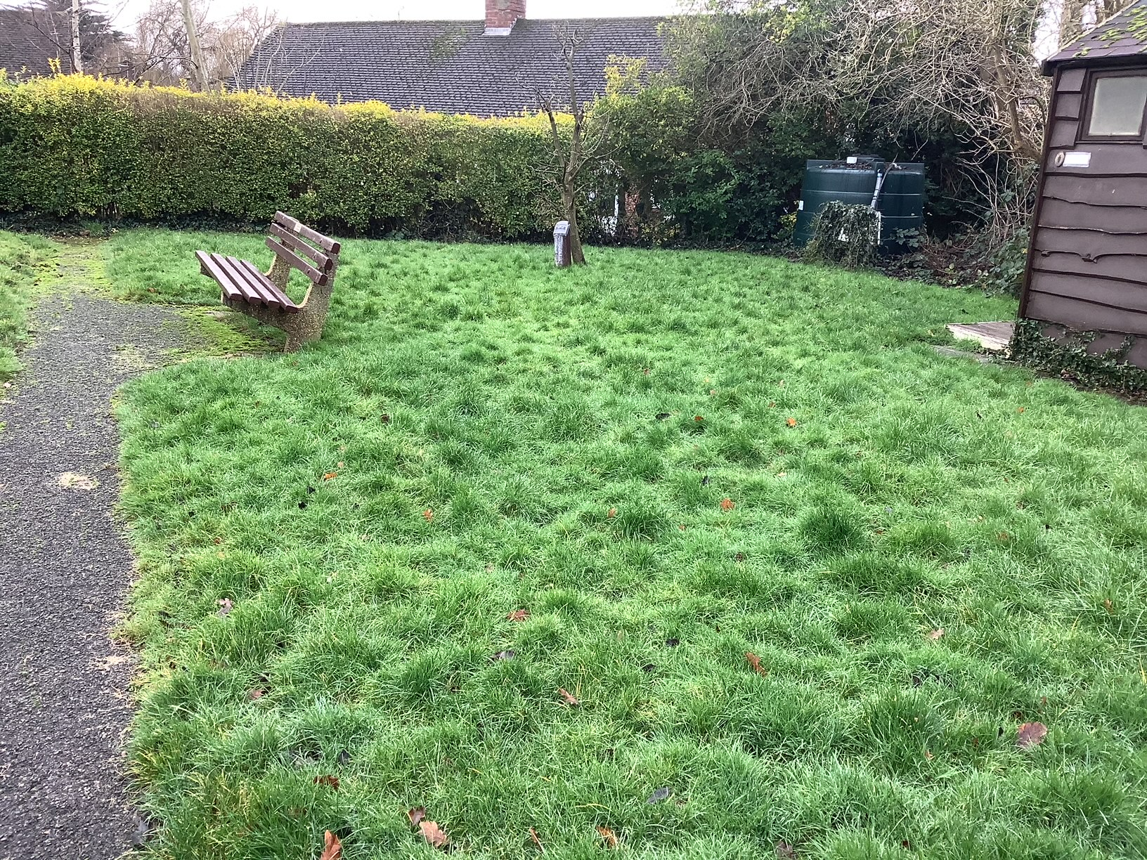

Please see the snap above from a previous magazine which shows what an untended verge can turn into. Just a few stalwarts share the onerous tasks of cutting this lot.

John Crosbie is hoping to set-up a group of members who can undertake hedge and ground maintenance on a regular basis. You would not be expected to work every week, but to be part of an organised rota ; rather like the tea or cleaning duties.

If you are able to join this intrepid band of helpers, then please contact John Crosbie.

Ed’s Note: We should mention some of the volunteers. President Rob, Anthony M, Richard S, Bob S and Bob W have been largely responsible for cutting, hedging and disposal to date. Andrew and Sarah are maintaining and planting some of the flower beds. Molly and Bob can be seen dead heading and pruning the roses, rather like an episode from Midsummer murders. And Colin has been tending his “wild patch”.

Well done all, and my apologies to anyone I have missed.

Committee Meeting

We actually managed a near full committee meeting last week. First this year and only the second since the pandemic began (we held an informal outdoors meeting last September – but no AGM this year nor last).

Hon Sec David R. will be producing official minutes in due course, but a couple of items may be of general interest.

Much of the discussion was about the problems with the green and ground; please see the previous paragraphs.

Our membership is holding steady, but is well down on previous years. Back in 2016 it stood at over 100 members; now it is nearer 60. We need to increase the membership to bring in funds so that we can maintain the club. More on this later.

Two current committee members indicated that they may not re-stand for election next year; Irene W who has done a magnificent spell at Catering.

And our Hon Sec, David R, who has done sterling work for many years. Giri K has indicated that he may be willing to stand in David’s place, but that then throws vacant the Social Secretary’s job; a very important role in augmenting the club’s coffers.

It’s also possible that other committee members may stand down, but no firm indications so far.

So, we are going to need a few more committee members next year. Please consider standing. If you would like to know what’s involved, please speak to any committee member.

Ed’s Note: I should point out that at the AGM, most candidates tend to be appointed nem. con. If you care to put your name forward, you are reasonably assured of being sponsored and selected.

John B, our Hon Treasurer will be issuing full audited accounts in due course, but it is worth remembering that we have quite large expenses. These include Turf Care at a tad under £5,000; general maintenance at £2,000 not to mention unforeseen repairs such as the electric roller blind. And of course, the grass and hedges.

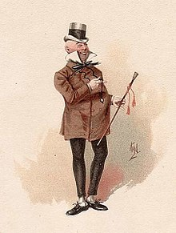
Without going into detail, we are just on the right side of the Micawber equation, showing a small surplus.

Mind you, these figures actually include some council Covid related grants and rent easements which will probably cease next year.

The long and short of it is that if we are to keep subs and match fees down, we need more members.

Obituaries

Joyce Candy – 1926 – 2021

We are sorry to report the passing of Joyce Candy, a long-standing member and a charming lady. She fully supported the social and bowling activities of the Club including tours abroad and in the UK.

She was cremated at Breakspear on 16th June; donations in lieu of flowers were requested for the Alzheimer’s Society.

RIP

Mary Bennett

Mary survived her sister Ann by just a couple of years. They were identical twins who rather enjoyed teasing fellow members about their identities. They did however dress slightly differently. One always wore grey skirts; the other wore regulation trousers. I thought I had them sorted by using a mnemonic of Annie Oakly (Deadwood stage) for trousers and Mary (Queen of Scots) for the dress, but I was never sure.

They were absolutely charming; I recall that in the days when this magazine was hard copy and printed at home, they would often send me an (unrequested) £5 note to defray the ink, stationary and postal costs.

RIP both ladies.

Membership Drive
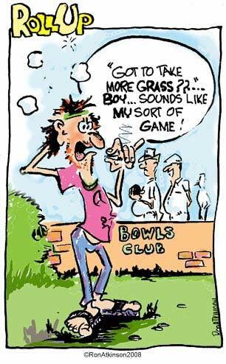

We really need to increase our membership, ideally with a few youngsters; that is anyone under 60!

Until recently, there seemed to be a couple of opportunities to attract potential members this summer. However, it’s all gone a bit Schrodinger’s Cat of late – you know, the moggy who was alive and dead simultaneously.

All down to Covid which may or may not come as a third wave.

The idea was to hold open days when the Pinner Association (PADCA) run the BIG BANDS in the Memorial Park this summer. The Bands are/maybe/won’t be:

Sunday 25th July: Harrow Steel Band. - Pinner BC Free

Sunday 1st August: Fats Rollini Jazz & Blues - PBC Away to Mill

Sunday 8th August: stardust Big Band - PBC Home to Court Park

Sunday 15th August: Simply Gray, Jive & Rock. - PBC were free

It was proposed to hold semi-open days Nothing over the top with bells, whistles and sirens, but just a billboard outside inviting passing folk to cross our threshold and have a go.

We needed perhaps half a dozen volunteers along if possible with our coaches and various captains of the leagues. A sample of the poster is displayed overpage

Problem 1: Amber Warning: As I write this, news comes in that Harrow Council have NOT yet approved the Band Concerts (because of the Covid virus). Despite much chasing from PADCA, Harrow are not expected to make a decision until this Wednesday! It is probably safest for us to cancel Sunday 25th July (Steel Band day).

Problem 2: Coronation Seni-Final Just a couple of days ago, we managed to win the quarter finals of the H & D Coronation Cup. Great news, except that the SEMI-FINAL is fixed for August 15th (when The Rock Band is on).

It may be possible to hold a open day later this year, or perhaps next season.

Banners have been produced and will be kept in store to be used at short notice.

A sample of the artwork follows.

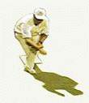
PINNER
BOWLING CLUB
Come In and Have a Go!
OPEN DAY
www.pinnerbowlingclub.co.uk

We had hoped to have 2 rinks available – ideally Rinks 1 & 2 – playing away from the clubhouse. Sheets down as necessary. Several sets of coaching woods, stickered up. More or less free form play with minimal advice from Pinner Members just to give public a feel for bowls. Leaflets would be made available (already drafted) and we would need someone to take down details of anyone interested for follow-up. If we could have gotten half a dozen or so takers, it would have been a good day.

Friendly Matches to Date

Pinner Friendly Matches
Opponents | Venue | For | Against | Result
Mill | home | 87 | 55 | win
Herts | home | cancelled
Rickmansworth | home | 94 | 36 | win
Harrow Weald | away | 43 | 48 | loss
Court Park | away | 90 | 71 | win
Marlow | away | 81 | 60 | win
Ruislip | away | 51 | 44 | win
Harrow | away | 69 | 62 | win
Harperbury | home | 40 | 42 | loss
Bessingby | away | 50 | 99 | loss
Bushey | away | 50 | 72 | loss
Marlow | home | 50 | 84 | loss
Deane Park | away | 79 | 69 | win
Ladygate | home | cancelled
Northwood | home | 63 | 46 | win
Oxhey | away | cancelled
Pavilion | home
Dean Park Ladies | away
Ladygate | away
Mill | away
Wexham | home
Harrow Weald | home
Court Park | home
Chalfont | home
Oxhey | home | cancelled
Harrow | home
Deane Park | home
Bessingby | home
Bushey | home
Wexham | away
Harperbury | away
Richmansworth | away
Chalfont St Giles | away
Ruislip | home
Totals |  | 847 | 788 | 59

Played 13, won 8, lost 5 with four cancelled. These matches are tremendous fun and a chance to socialize with other local players. Do consider putting your name down for future games.

Harrow and District Leagues

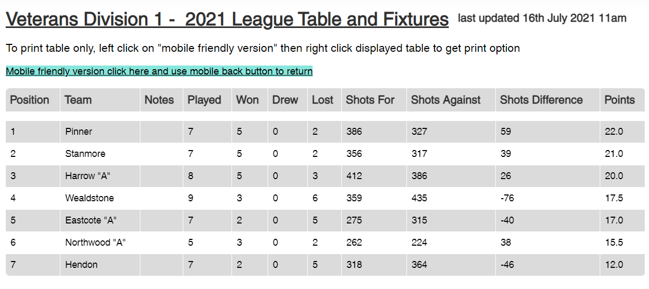

Well goodness, gracious! After 7 matches, in our rightful place at the top of the league. Keep it up chaps and chapesses.

Note: The vets. is a Harrow and District League for over-60’s men, although limited numbers of ladies may play. Teams comprise 3 * triples and points are awarded 1 per game and 2 on aggregate. (5 pts max).

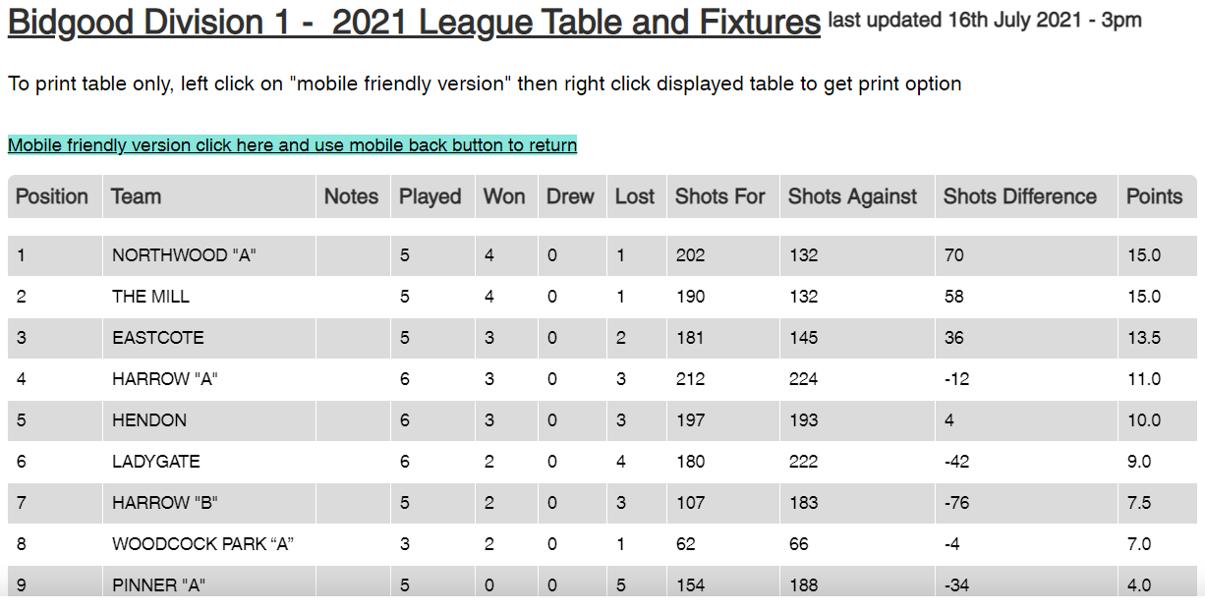

Played 5. 11 to go to avoid relegation!.

Note: Match comprises 2 triples each side, mainly men (limited ladies) and play usually commences 1800 hours. Intended for players who work during normal day hours. Tends to be very competitive.

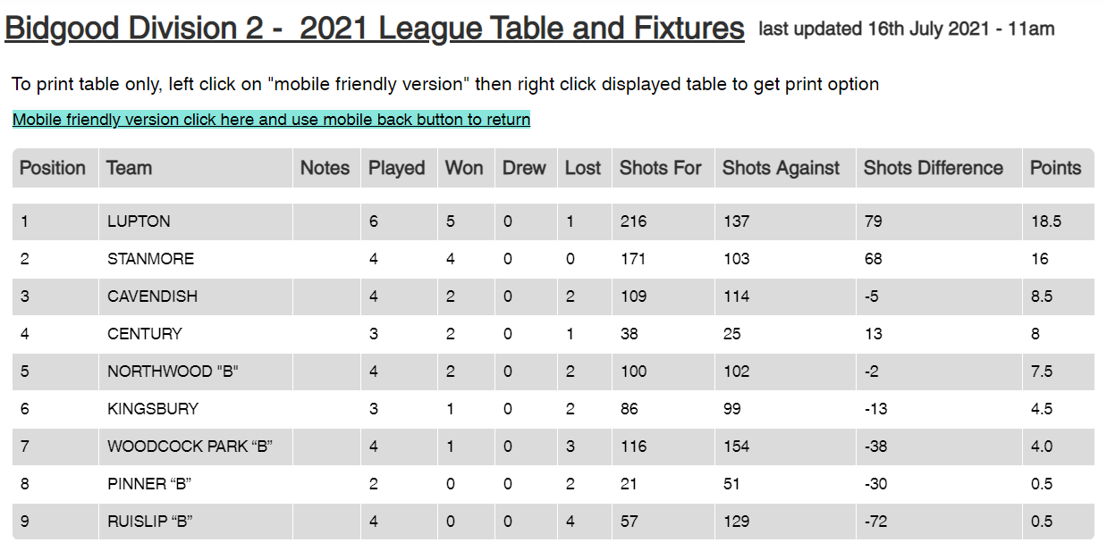

Played 4. Drawn a single game. There has been difficulties in getting a full team out. Some discussion about whether to field two teams next season. Any volunteers to take on the second team? If no takers, it is likely that the B team will fold next year.

Other Harrow and District Competitions

Coronation Shield: Home and Away simultaneously. Two full Rinks.

The match was played in blistering heat. The “home team” managed to keep their noses in front for most of the game.

Our “away” side struggled at first giving away a 6-shotter, then a couple of three’s. (Although we did manage a rather raggy fiver ourselves).

On occasion we were holding several, but Woodcock rather unsportingly kept trailing the jack. We eventually crept back single-shot by single-shot and won the last 7 or 8 ends to get within a shot. Thank goodness for 21 ends.

Our friends at Woodcock were most magnanimous in defeat and insisted on standing the beers. Most welcome in the heat.

We now though to the semi-finals where we play Eastcote scheduled for 15th August.

Portman Cup: Comprises a singles, a doubles and a triples, overall score on aggregate. We had a narrow loss to Mill 45 shots to 50.

Triples: Richard Segalov’s triple has reached the semi-finals. It is to be played at Pinner Wed 18th Aug at 1800 hrs. Good luck all.

2-Woods: Colin J has reached the quarters.

Should any of our participating players care to send me copy of matches I will publish in later issues.

Friendship Cup: West Harrow
First Leg 14th May | home | 69 | 54 | win
2nd Leg 16th July | away | 91 | 78 | win
Aggregate | +28 |  |  | win

A yearly event against our good friends from West Harrow. We managed a good win this week and retained the cup. But really, this is not what it is all about and we enjoyed a very pleasant social drink afterwards.

Markers Wanted

We run several knock-out internal competitions. All of the singles matches need to have markers to centre the jack, look after the mat, take measures, advise on who is holding shot if asked, keep the scores and so forth.

Without markers the matches cannot take place (strict club rules).

There is no tangible reward, although the marker will expect a drink or two from the players; and perhaps reciprocal favours when they themselves have a match.

Markers are urgently needed; our Hon Sec, David maintains a list of people willing to mark. Please consider adding yours; you never know when you will need a marker yourself.

Forthcoming Events

Fish & Chip Supper Drive: 25th August; Wednesday Evening

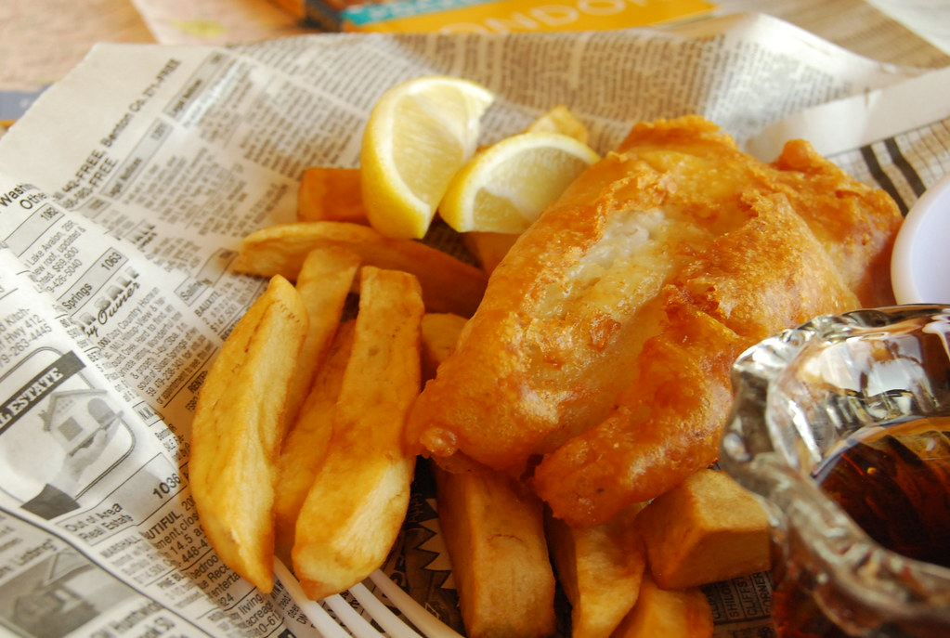
It is planned to organize a fish & chip supper drive. For those who have not attended before, it is tremendous fun.
This Photo by Unknown Author is licensed under CC BY

Because the Covid situation is still fluid, it is not absolutely definite yet; but please watch the notice board and your in-box for updates.

PS For non-piscatorians, chicken is usually available; or even fried Mars bars.

Annual Dinner Wednesday, 10th November, Grimsdyke Golf Club.

Also a bit up in the air.

Because of the potential Covid “third wave”, the holding of the annual dinner is in some doubt. Please watch the notice board and your in-box for updates.
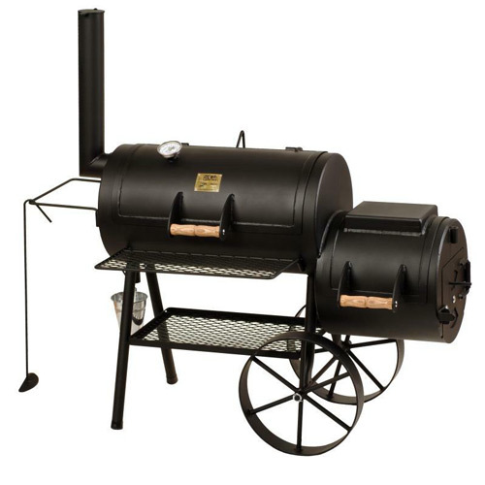

Should the dinner NOT go ahead, it is possible that the Trophies will be presented at finals weekend in September and that a BBQ will be organized instead of a formal dinner.

VP Marion is dealing.

Loss of Form – Some Musings

It’s always a little frustrating when you lose form and you cannot find line, length or even the right bias!

Forty years ago this July, Ian Botham had just suffered 12 test matches without a win. He was then out for a duck at Lords, of all places! The suits at the MCC relieved him of the Captaincy of England. Doom and gloom all round and newspapers full of it.

Two weeks later, up at Headingly, England were once again being stuffed by the Aussies.

Along comes Beefy; 6 wickets in the first innings! And a 50 with the bat.

Then in the second innings, he scored an unbeaten 149. With a little help from Bob Willis – 8 for 43 – he snatched victory.

The point is that your form will usually return. Just keep practicing. I’ve even played the odd bad game end myself!

Some ideas that seem to work are:

Talk to one of our coaches; we have three of the best.

Many of us are getting older and have problems gripping the bowls, especially when wet. How about trying going down a size or two? You can always try someone else’s woods – do ask. Or try the coaching woods. And a second hand set can be had quite cheaply. The great David Bryant used to advocate this; in fact he always carried at least two different sets of woods, deciding which set to used depending on the conditions.

Bowling Glove. (costs under £10). Many sports wear gloves for better grip. Goal keeps, golfers, pool players and so on. Some sports ban gloves because the extra grip is deemed unfair; cricket fielders/bowlers, petanque where you back-spin the boule. Why not give a glove the try?

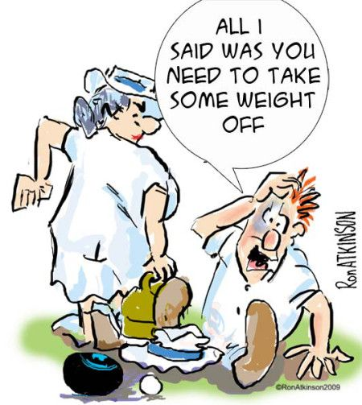
Talking about coaches, we could use extra coaches.

Normally a course by Bowls England costs around £120 or so, plus expenses. The committee are looking for volunteers to apply for coaching course; if selected, the club will sponsor and pick up the fees.

Please let any of the committee officers or coaches know if interested.

Pinner Web Page
Just a reminder that we now have a good web page run by Anthony M.
Amongst other features, it maintains a list of all fixtures and results to date.
I understand that Anthony intends to add hyper links to other local Bowling Club web pages which can be used for instance for directions to other clubs. In the meantime, Stanmore web page keeps quite a good address database if you need directions to other local clubs.

Web Address is www.pinnerbowlingclub.co.uk

Make sure you log onto the right web page as there are three or four others that mention us (such as PADCA, Bowls England) and a Google search may throw these up. The info on them is mostly incomplete and often plain wrong.

Enjoy your bowls

Mike Jones

Any copy, please to:

michael.k.jones@btinternet.com

