Pinner Bowls Magazine

Issue 35 – June 2021

Mid-Summer Edition

Ne’er Cast a Clout ‘til May be Out

Rarely was an old saying so apposite! Just as the Covid lockdown looked like easing slightly and a glorious summer of bowling beckoned, the heavens opened with rain and hail driven by a wicked nor’ easterly wind.

We may well have lost Miserable May, but at last we are seeing signs of Glorious June; a little too much if anything as the temperatures soar to the high twenties Celsius. It was certainly never this bad when we used ^{O} Fahrenheit. Still we are now set fair for a good season of bowling and the committee look forward to seeing you all on the green.

Stop Press: Surprise, surprise; it’s raining again! Must be something to do with the Summer Solstice; from this week the days start drawing in!

Covid Comments

With any luck, we are almost over the worse of the plague; although different local clubs seem to be handling things slightly differently.



We had an away match against one of the stricter clubs, who shall remain nameless, but also live near a duck pond. They insisted on:

No visitors; although our travelling ex-President Molly was permitted to spectate as a concession.

Separate jacks, yellow for away and white for home, to be touched only by the appropriate lead

Ditto for the foot mats, black and blue.

The bowls scoops to be operated by the number two’s only; home at the clubhouse end, away at the mill end. This caused great consternation as usually the scooping job is left to the losing lead; I’m not certain that the regular twos knew which end of the scoop to push. Watching them gathering up 18 woods was like watching someone herding kittens!

Clubhouse out-of-bounds for visitors unless answering urgent call of nature; and then full mask and sanitizing job.

Also meant getting changed outside.

No after-match drinks as Covid had not allowed them to stock up the bar! A likely tale, the more uncharitable thought.

As it happened, it was the Farmer’s Market Day adjacent to the green. A couple of stalls were selling homemade beer and cider. I think we missed a trick there.

Other clubs, who I shall not name either, in case they are all arrested and sent to the Antipodes, welcome you like long lost kissing cousins. They work on the principle that two doses of vaccine are more than sufficient, especially if fortified with a glass or two post-match.

As I write this, there is still some doubt about the end of lockdown date; end of July? Perhaps – perhaps not. We need to recruit some new members and hold some open days, but this is not really possible until we have the official all clear.

In the meantime, we soldier on and thanks to our organizers and various competition Captains, there are some results to report.

Just a few years ago, we at Pinner played few competitive inter-club games. Virtually all matches were mixed friendlies; in fact we were known locally as “The Little Friendly Club in the Corner of the Park”. Extra bowling was either via the various intra-club knock-outs, the occasional drive and organized roll-ups.

Nowadays of course, we tend to get involved with the more competitive Harrow and District matches; the Veterans League, The Bidgood League and the H & D knock-outs.

First, an update on the friendlies.

Friendly Matches to Date

Pinner Friendly Matches
Opponents | Venue | For | Against | Result
Mill | home | 87 | 55 | win
Herts | home | cancelled
Rickmansworth | home | 94 | 36 | win
Harrow Weald | away | 43 | 48 | loss
Court Park | away | 90 | 71 | win
Marlow |  | 81 | 60 | win
Ruislip | away | 51 | 44 | win
Harrow | away | 69 | 62 | win
Harperbury | home
Bessingby | away |  |  | lost
Marlow | home
Deane Park | away
Ladygate | home
Northwood | home
Oxhey | away | cancelled
Pavilion | home
Dean Park Ladies | away
Ladygate | away
Mill | away
Wexham | home
Harrow Weald | home
Court Park | home
Chalfont | home
Oxhey | home | cancelled
Harrow | home
Deane Park | home
Bessingby | home
Bushey | home
Wexham | away
Harperbury | away
Richmansworth | away
Chalfont St Giles | away
Ruislip | home
Totals |  | 515 | 376 | 139

Played seven, won 6, lost 1 with one cancelled. These matches are tremendous fun and a chance to socialize with other local players. Do consider putting your name down for future games. Many thanks to our fixture sec Gary W for all his hard work in arranging the matches and to Captain Bob W in running things.

Stop Press: Just been well sorted away to Bessingby. We lost all 4 rinks, but at least we won the wine raffle FOUR to NIL. So result!

I should also mention the selection committee, but I’m assured that they all sleep like babies. It’s just that they tend to wake up in the middle of the night screaming!

Harrow and District Leagues

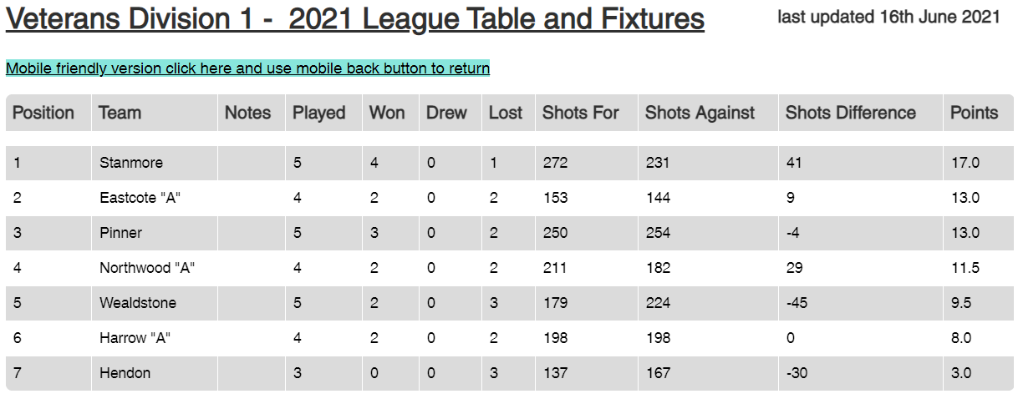

At the beginning of June, we were riding high in division 1 (of 3); second place with 3 wins from 4 played. However, a recent reaming out by Wealdstone (1- 4) has seen us slip to 3rd.

The vets. is a Harrow and District League for over-60’s men, although limited numbers of ladies may play. Teams comprise 3 * triples and points are awarded 1 per game and 2 on aggregate. (5 pts max).

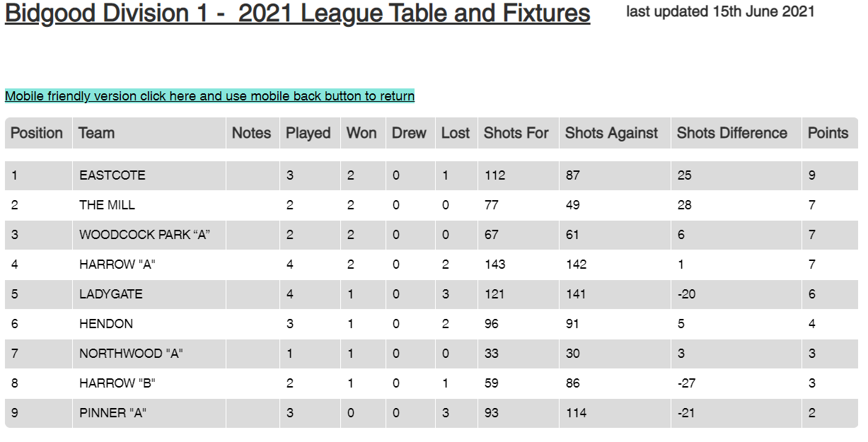

Just like Atlas, we are supporting the World on our shoulders.

At least we won two individual triple games from 6 played. ‘Nuff said.

Match comprises 2 triples each side, mainly men (limited ladies) and play usually commences 1800 hours. Intended for players who work during normal day hours. Tends to be very competitive.

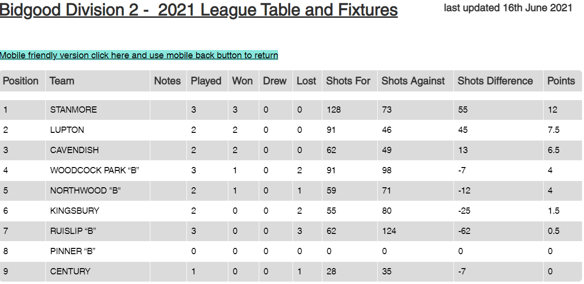

Our B team have not yet played. First match 17th June. A chance for glory or at least to outshine the so-called A team!

Incidentally, I understand that the B team are looking for players. Please let Captain Rob know if you would like to play. Ladies welcome.

Other Harrow and District Competitions

Pinner played Harrow in the first round of the Coronation Shield. We managed a win 42 to 32 shots.

We have entries in the singles, double and 2-woods etc, but no results yet on the H & D web pages.

Should any of our participating players care to send me copy of matches I will publish in later issues.

Friendship Cup: West Harrow
First Leg 14th May | home | 69 | 54 | win
2nd Leg 16th July | away
Aggregate

A yearly event against our good friends from West Harrow. Do consider putting your name down for leg 2.

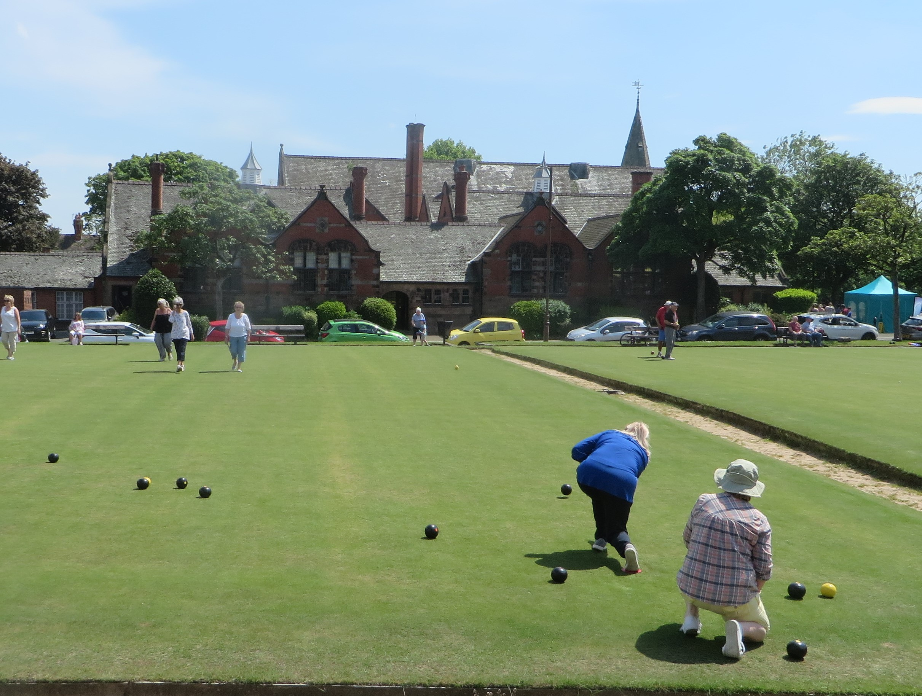
Bowling Up North John Crosbie took this snap whilst up in the Wirral Wilds – well, Port Sunlight near Birkenhead. Port Sunlight bowls club is a bit of an oddity, combining as it does the elegant uniform of the Cheshire Scouser with a complete ban on alcohol! Lord Lever, the founder, was a Quaker. The snap shows two greens. I am told that one is for men; the other for ladies. I offer no comment, although I wonder who puts out the equipment.

Meanwhile, just across the River Mersey in Wigan, they have an unusual delicacy called a “Wigan Kebab”. It’s a meat pie inside a bap!

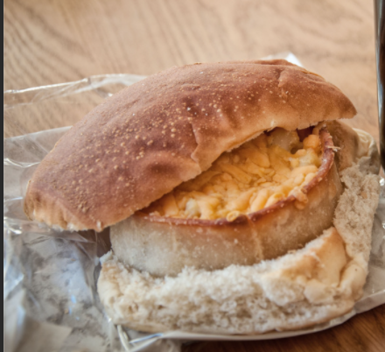

Now there’s an idea for our next BBQ. Note: Footy fans may know that Wigan are known as the “pie eaters” for reasons that date back to the general strike.

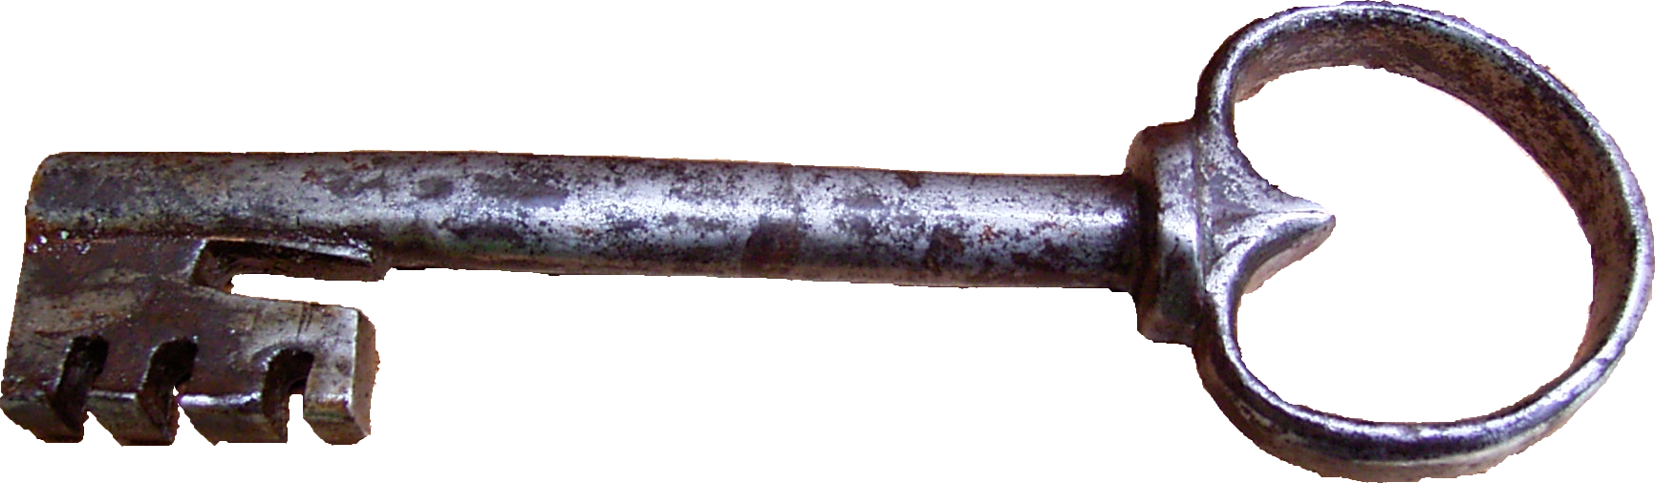
Keys and Things As things get old and ancient, they tend to wear out. Not just Pinner Players, but our equipment. First, our clubhouse roller failed. £180 call out and another £200 to repair the motor. Thanks to John C for organizing the repair.

Then the padlock on the equipment shed jammed shut; and the spare also jammed. New Squires 660-style padlocks cost around £15 each.
And things go in threes! The deadlock on the clubhouse door keeps sticking; which could result in us being locked out of the clubhouse. We need to get a locksmith in to check things out, but if the lock needs replacing, we will also need 60 plus new spare keys for those members who hold and full sets. Not likely to be cheap.
In the meantime, will all members refrain from locking the clubhouse doors? We need to rely on the roller blinds until further notice.
Thanks
PS Just tried the sheets box; padlock jammed on that as well!
From Our Fashion Correspondent Jessie: New style bowling bag

Pinner bowling club members may be interested in this new bowling bag from the Cambridge Satchel Company.
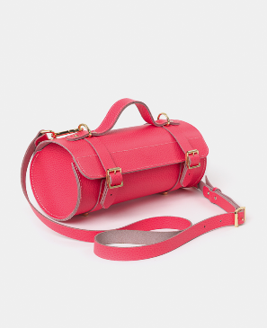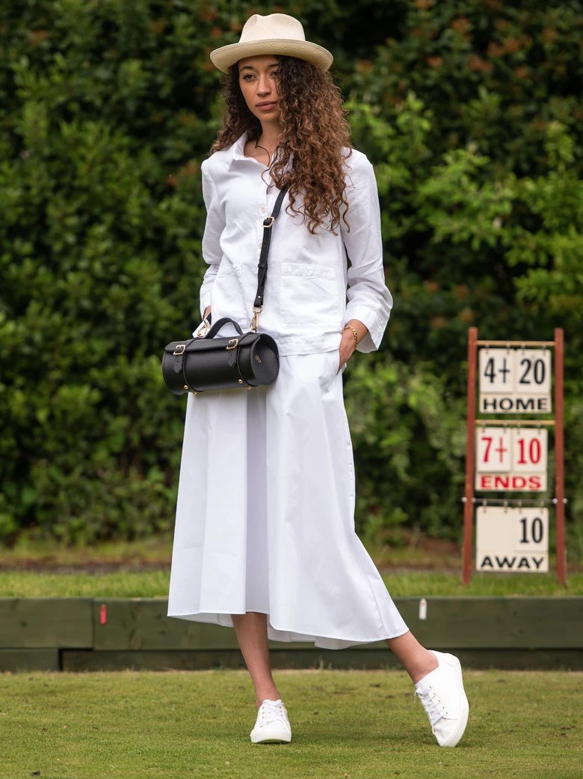

The company were inspired to create the new bag when they found a 1930s one at an antiques fair and realised that it was designed to carry two wooden bowls. They have updated the bag for the modern fashionable world so there are magnetic clips, a detachable shoulder strap and little legs on the bottom. It is a gorgeous practical bag, made in the UK from 100% leather. It is available in six beautiful colours including pink, light blue, red and oxblood, as well as the standard brown and black.
It would be fantastic to see all the Pinner bowlers carrying these stylish bags. It is priced at just £195 and for £7 the company will personalise the bag for you. P&P extra.

Available from their website: https://www.cambridgesatchel.com/ or from Liberty or the company shop on Neal Street. Jessie Atack

Ed’s Note; Might go with the new strip – see later.

Markers Wanted

We run several knock-out internal competitions. All of the singles matches need to have markers to centre the jack, look after the mat, take measures, advise on who is holding shot if asked, keep the scores and so forth.

Without markers the matches cannot take place (strict club rules).

There is no tangible reward, although the marker will expect a drink or two from the players; and perhaps reciprocal favours when they themselves have a match.

Markers are urgently needed; our Hon Sec, David maintains a list of people willing to mark. Please consider adding yours; you never know when you will need a marker yourself.

Car Parking; The On-Line Vigilantes

Just a mention in passing. I’ve noticed a minor “storm” on the local Neighbourhood sub-set of What’s App.

It seems that many folk are completely distraught about the Eastcote/Cavendish bowls club parking on the grass outside their club instead of using the official car park – usually full by the way – or the distant car park near Bessingby about a km or so distant. It has been reported to the council who have promised to take action.

We don’t have a dog in this fight, although our members have used the grass when directed to do so by Eastcote (hosting a major bowls event).

Just worth pointing out that we probably need to watch our own parking and not park off-piste near our gates unless conducting genuine maintenance etc.

Usual Call for Grass Collection

As you all know, we now do our own maintenance. Help needed to cut verges, hedges etc, but MOST importantly, to get rid of the rubbish. If you can help by taking a sack or two of cuttings and put them in your own Brown Bin, please speak to any committee member; or just grab a bag on your way out.

Manning Triples A grand day out organized by Gary and Bob S. After the usual last minute drop-outs we ended up with 21 bodies, just sufficient for 7 triples.

The triples were played as a partial round Robin; three sets of 5 ends sitting out one set. The match was of great interest as several of our new members played in a major competition for the first time.



Gary, Bre and Roy took the honours; they are the ones holding the silverware. The runners up were new players Vera and Ed Badke, skipped by Rob. They reached the finals without losing a game.

The odd chap in the middle is Bob, our compere for the day.

I must also mention Lorraine Welsh who, poor lass, playing in her first competition was in my team; she played like a star and we missed out on the final by a single point on shot difference. (To the eventual winners).


Club Strip? Nothing official, but informal off-line chat suggests that there may be a case for a club match strip. It seems to be the thing amongst Bowls England and many Harrow and District Clubs. By the way, this pic is not the proposed strip; although official Pinner colours are blue and yellow. There are pro and con arguments to be made and no doubt any proposals will be put to the membership in due course.

I am neither for nor against, but I’ve never really seen the point of wearing uniforms unless there is good reason to do so.

Army or football teams, yes. Otherwise might shoot wrong person or pass ball to opponents. (Could England do with a more distinctive strip)?

Cricket team? Unlikely to bowl at wrong player. It’s the chappie with the bat.

Not quite sure where Bowls fits in. Certainly some players seem to aim at own side’s woods; especially when I’m holding shot.

Any comments? I will forward to the committee.

Casual Wear? Another meme that seems to be going the rounds is for players to be allowed to dress in casual wear for roll-ups and casual games. Rather than the “official” colours of grey trousers/shirts and white everything else; reminds me a bit of school uniforms back in the 50’s or 60’s. And of course, navy blue jackets and regulation trousers, whatever regulation means.

I see that several local clubs allow any sort of casual dress, including jeans and T-shirts for roll-ups. I hear on the grapevine that a proposal may be put at the next agm.

Roll-Ups

Now that the Monday Aggregate and Wednesday and Thursday Leagues are no more, there has been a call for more roll-ups. The problem as always is getting volunteers to run things on a regular basis.

Gary W has made a start and ran a combined “Club Day” / “Roll-Up” a couple of Wednesdays ago. Apart from Gary, 12 members turned up and enjoyed a few competitive and fun ends.

David R had scheduled this Friday for a repeat, but torrential rain has stopped play.

If there is a genuine call for organized roll-ups, then we will need members to open up and run things. Any volunteers?

New Web Master?

I understand that Anthony Muzlish has volunteered to take over the running of the Pinner Bowls web page. Our thanks to David R for past work in setting up the current pages. And well done Anthony for volunteering; I look forward to developments. Anthony has asked that any suggestions for content be forwarded to him. anthony@muzlish.eclipse.co.uk.

And finally

You will all have heard the old parody on Shakespear’s “Ages of Man”,

Lager

Aga

Saga

Gaga

A new one appeared in the Times recently:

Tri Weekly

Try Weekly

Try Weakly

I’m sure they were talking about bowls.

Enjoy your bowls

Mike Jones

Any copy, please to:

michael.k.jones@btinternet.com

PS We need more lady players

