Pinner Bowls Magazine

Ne Simus Brevis

Issue 37– September 2021

Close of Season Edition

The Old Club Motto

The last two or three issues have been pretty well devoted to gardening issues; and whilst the green, hedges and grass remain concerns, I shall start with a diversion. Our readers may have noticed that we have reintroduced the old club motto “Ne Simus Brevis” to the letter head. It is of course dog Latin for “Don’t be Short ”, a general admonition from Skips to long suffering Leads. (And sometimes muttered by said Leads when Skips do not quite manage a full length themselves).

Dog Latin was all the fashion back in 1953 when this club was first formed; and nothing wrong with that as such, but how many of us could translate the phrase nowadays even with recourse to google?

Our logo is also of this vintage; you know, the picture of the old West Lodge House.

West House has not looked like this for a while now. Do we need a new logo? Or if not, perhaps at least to choose which one of several in use that we want to standardize on? I have tried to find the original artwork, but to no avail.

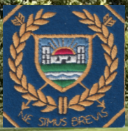

The first is a facsimile of our blazer badge; it has been used on recent Annual Dinner menu and notice boards.

The House does look a bit like the Edvard Munch picture, “The Scream”!

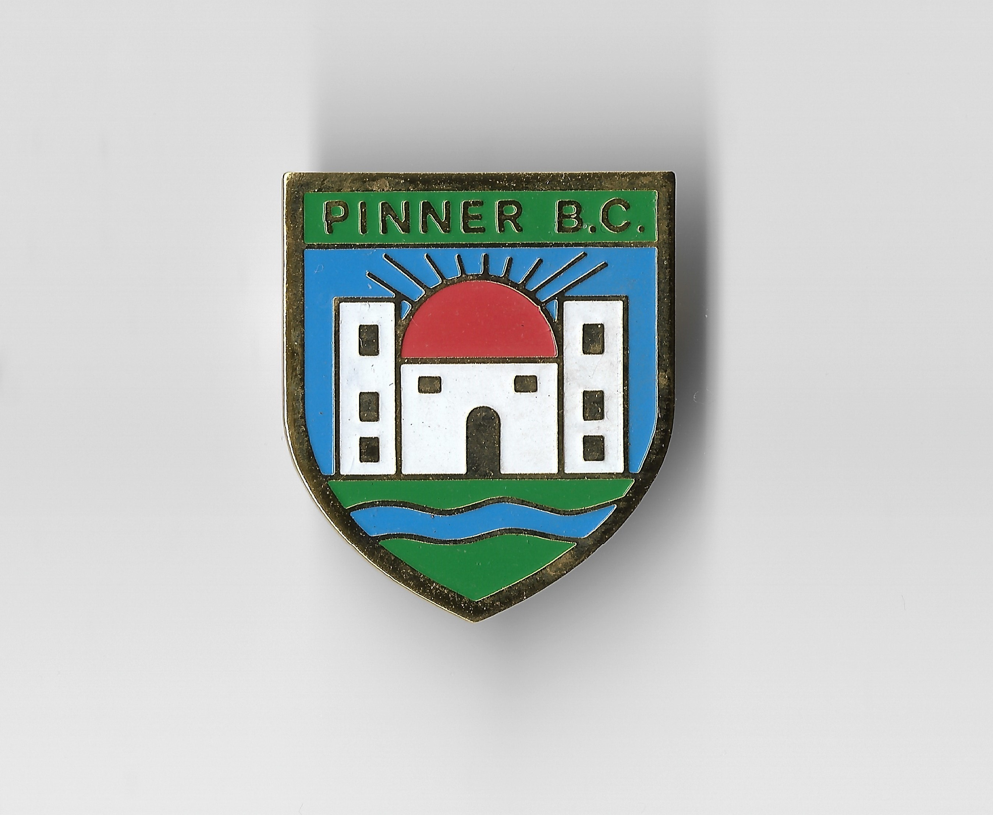

This is the lady badge version. The house is saying “Argh”! Must have seen our results in the Bidgood.

Quite a crude version produced on either PowerPoint or Freelance some years ago. At least it looks vaguely happy (or smug) and is quite bright. Used in this magazine and on publicity posters.

As used on our 50th Anniversary banner.

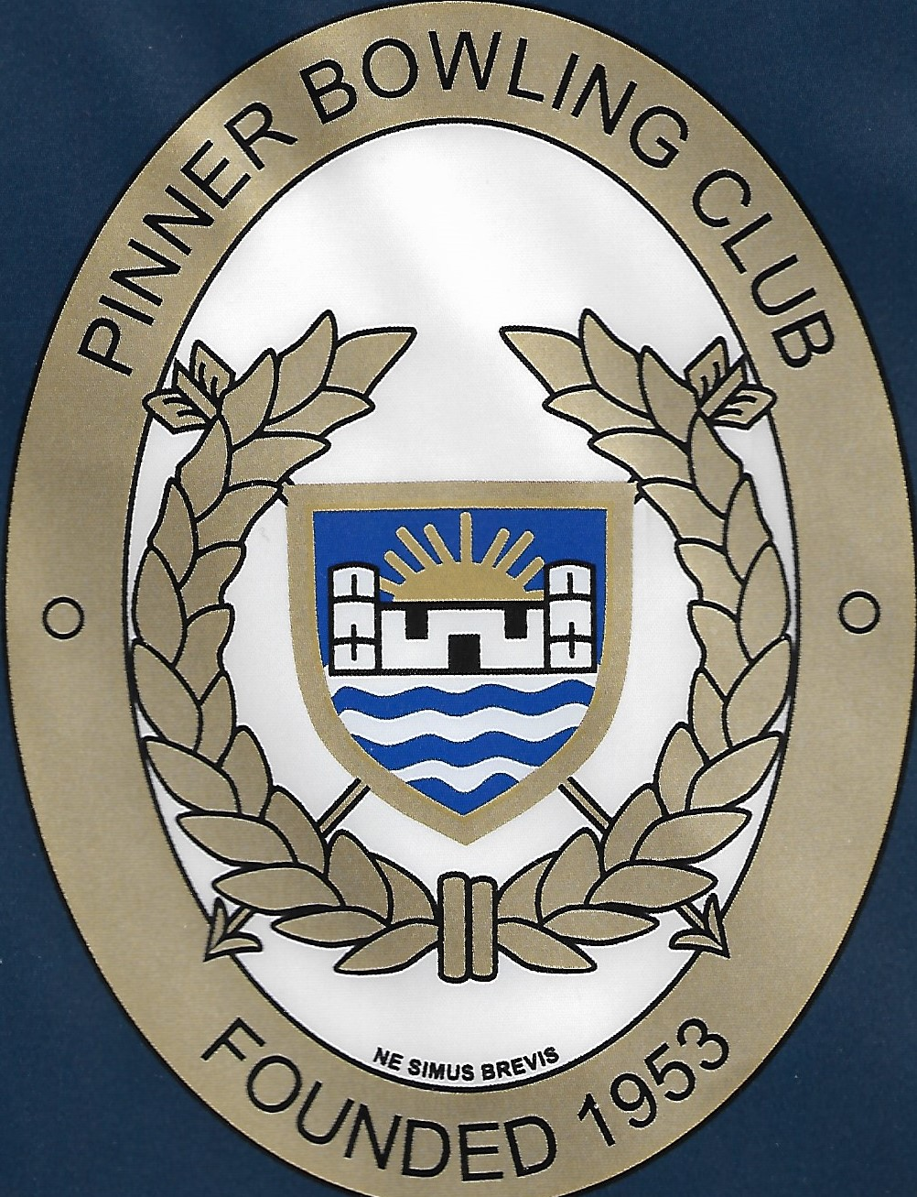

Probably the most elegant version, although the colours are a little muted. The full jpeg is very large @ well over 50Mb (this is a low resolution copy).

The house looks like it has just been goosed and does not mind too much.

Does anyone have the original artwork? Or should we redesign the logo to reflect modern times. Your views most welcome.

There will be no prizes for suggesting pictures of foxes or crows!

Greens and Grounds and Grassy Surrounds

Ok, put off long enough. One of the main current concerns is the state of the green and the surrounds. And the cost and logistics of getting or keeping them up to scratch. There are several problems
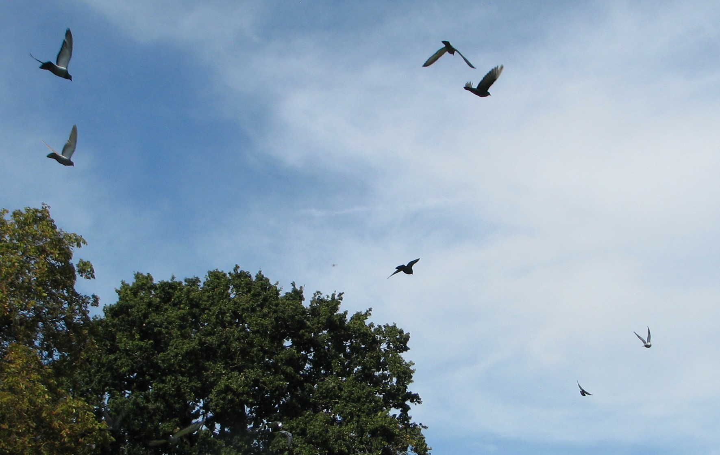

It’s Dinner Time!

i) The Green and the Local Fauna

Over the summer, our green has been suffering prolonged attack from the birds; mainly crows. They just keep digging holes searching for who knows what. As fast we fill the peck marks in with sand, they just scour them out even more.

One theory is that the birds are actually attracted by the sand. They take it into their crop and it helps to grind down their food. Sharks and other creatures swallow small stones for the same reason.

Various counter-measures have had varying degrees of success. The final initiative was to string old CD discs from bamboo tripods; rotating in the wind they had a stroboscopic effect that was hoped would deter the birds. For a while, it seemed to work; until; -----

Along came Brer Fox and family. They loved the new toys and proceeded to dig big holes directly below the dangling discs. Rob sent this pic.

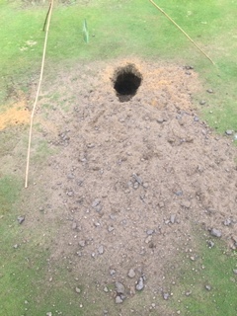
This is but one of several holes. Just for fun, I reckon.

Now you are not allowed by law to kill foxes by drowning in a water butt, gassing with a car exhaust, stabbing, poisoning, bludgening and so forth on risk of a £5,000 penalty; or even gaol.

You are allowed to shoot them, but only with a gun license, minimum 0.22 caliber and nowhere near a public highway or path. You can kill them with a lethal injection, but only if a qualified vet or DEFRA official. You can catch the little so and so’s with a humane cage trap, but you are not allowed to release them where they could be a nuisance to others. (So we could not dump them on someone else’s bowls club).

And so, hence the reintroduction of the fox fence.
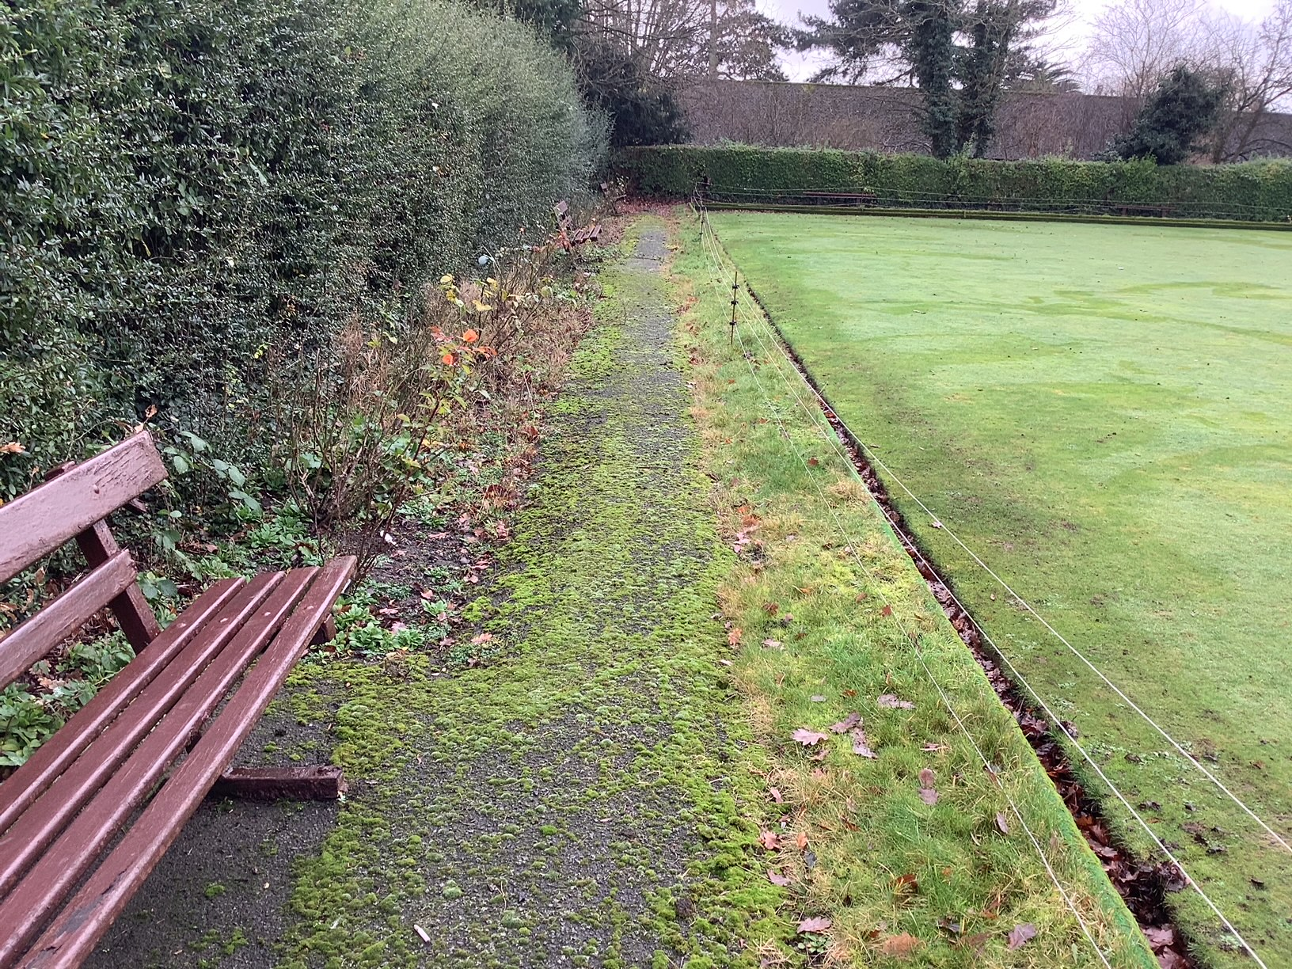

This, as you can see is a bit of a pain; possibly quite literally. It is a mere 20,000 volts DC, so should you attempt to stride the fence, it will give you a nice tingle in your nether regions.

Normally, the electric fence is close to the boundary of the club grounds, but because the hedge is so overgrown, it has been necessary to erect it (at least temporarily) just fringing the green. This effectively isolates the green itself from the surrounds, including the pathways and benches and the clubhouse. It seems to have had a partial effect, but our green keeper and grounds team are still waiting to evaluate the results.

ii) The State of the Green

Aside from the animal damage, the green has not been playing too well. And the maintenance contract is one of our major costs; see reports and accounts for details.

The committee are considering ways and means of improving the situation, but details are beyond the scope of this magazine.

iii) The Hedges and Grass Surrounds

Now that Harrow Council do not maintain the grounds, the hedges and grass surrounds are our responsibility. A few of our members have been regularly cutting back the hedge, but it is extremely hard work and it is a problem to dispose of the cuttings.

The options seem to be to get contractors in at a cost of around £1,500 a year or to form a dedicated working party under the direction of the green ranger. A party of several people would be needed and all members would have to help dispose of the hedge and grass cuttings. And a big thanks to all who have taken bags home for their wheelie bins.

If we have to pay the £1,500, obviously we will need to raise the cash somehow. Ways and means being discussed, but could involve several special social events, a recruitment drive to raise more subs, increase match fees and raise green fees for casual play; or perhaps an increase in subscriptions. (£1,500 between say 50 players = + £30)! This is arguably more than the club members could stand.

A more likely scenario is that we will have to raise the extra yearly mony by a combination of all of the above.

So there you have it. The green and grounds are expensive to run. If we are to continue to enjoy our outdoor bowls, we need regular volunteers for ground work, perhaps along the lines of having a rota for teas and cleaning duties.

And/or more money for external contractors. Your views most welcome.

Obituary

Trevor Thomas 1934 - 2021

We are sorry to have to report the death of long-standing member Trevor Thomas, husband of Christine and father of two daughters, Natalie and Charlotte.

Trevor was a cheerful character and a most enthusiastic member of the club.

All of our regular leads have cause to be grateful to Trevor as he was the maker of most of our rather unique wooden bowls scoops.

He was cremated at Breakspear and donations were divided between the Macular Society and the Harefield Hospital Trust.

Rest in Peace

The Committee
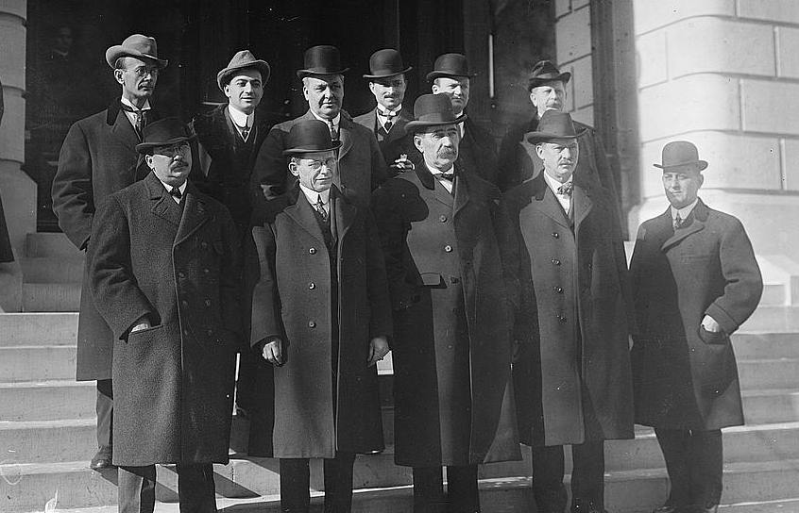

You will all have seen diverse e-mails from the Hon Sec asking for nominations for next year’s committee; to stand at the AGM in February.

According to the constitution there should be eight Officers plus four general playing members. In practice, as work has increased, the number of general members has also increased to cover certain nominated tasks. Here is the current state of play. Officers in blue type; General members in orange italic. Other essential but not necessarily committee posts are shown in purple italic.

Post | Current Incumbent | Proposed
President | Rob Atack | Colin Jones
Vice President | Marion Baxter | Bob Webster
Secretary | David Rumsey | David Rumsey
Treasurer | John Brooke | John Brooke
Match Secretary | Gary Welch | Gary Welch
Social Secretary | Giri Kanuga | Rob Atack
Captain | Bob Webster | Marion Baxter or Bob Spencer
Vice-Captain | Bob Spencer | Anthony Muzlish
1: Green Ranger | Keith Dawson | Richard Segalov
2: Maintenance | John Crosbie | John Crosbie
3: Catering | Currently unfilled (was Irene Wiggins) | Irene Wiggins and/or Molly Spencer
4: Marketing & Lockers | Mike Jones | Tony Moore
Web Master | Anthony Muzlish | Anthony Muzlish
Capt. Vets Team | Gary Welch | Gary Welch
Capt. Bidgood A * | Richard Segalov | Richard Segalov *
Capt. Bidgood B * | Rob Atack | Rob Atack *

* Assuming we put up two Bidgood teams next year.

Although we have nominations for all posts, anyone may stand for any position, the result to be decided by ballot at the AGM. If interested see the club notice board or advise Hon Sec or President. A proposer and seconder required.

Results This Year

A Write-Up from Match Secretary, Gary Welch

Note Because of late Issue of this magazine, some of the events have been updated in orange.

Gary writes: Harrow & District Competitions

Veterans League
At the start of the season the object for Pinner in the Vets League Division 1 was to try and stay up. We were promoted in 2019 after finishing runners up in division 2.
Pinner after 9 of the 12 matches were in mid table and we were 3 points from achieving our objective of staying up. Our remaining 3 matches were at home against Northwood, Wealdstone and lastly Stanmore.
On Thursday 19 August we had a very tense 3 rinks match against Northwood and with 2 ends to go we trailed by 10 shots and it was looking like a win on a rink and losing 2 rinks. We managed to turn this around to get 2 draws 18 all, 15 all and a win 18-16. 4 points.

Friday 27th played Wealdstone and were always in front overall but very close on rink 1 which was overturned with 3 ends to go and ended in a 19-16 win the other rinks won 21-8 and 37-10. 5 points.

Pinner now have an opportunity to win Vets League Division 1 on Friday 3rd September we need to beat Stanmore which is the final game in the league this year. We need to pick up 4 points to win the league.
In fact we picked up 3 points only; a magnificent effort winning on aggregate, but losing two of the games by the odd point! MKJ

Harrow and District Triples
Pinner hosted the triples semi-finals on Wednesday 18th August. We had an excellent turn out to watch the matches. Pinner were represented by a team of Anthony Muzlish, Richard Segalov and Colin Jones. They played a team from Eastcote and gradually pulled away for a well-deserved 20-12 win.
They play a Team from Harefield at 10.00 on the 4th September at Lupton B.C. in the final.
Unfortunately, they suffered a narrow loss in the final. Damn good effort. A match report will appear in a later edition. MKJ

Coronation Shield
On Sunday 15th August we played Eastcote home and away in the Coronation Shield semi-final. The away team won their match 23-13 which made it easier for the home team which lost by 1 shot 18-19 giving Pinner an overall win by 9 shots.
The final is on 4th September at Lupton B.C. against Harefield at 14.00.
A win at last! Report follows later in this magazine.

A very busy few days for Pinner as we also have a Vets Cup semi-final at Harrow on Monday 6th September against Stanmore at 14.00.
A win by 51 shots to 43.
But then 3 days later also at Harrow, a loss to Northwood in the final by 47 to 58!

Gary Welch

Additional Report on the Lupton Match; Coronation Shield Final (Two rinks of 4 played simultaneously). MKJ

Strange place, Lupton. Hard up against Cannon Park tube station, parking is often difficult because of commuters. But it was a Saturday, so the station car was for once empty. The problem was that the car park was full of dire warnings about non-payment; it was bristling with camera. The first notice said “Pay on the way out at the toll booth”; but the booth was locked up and of human parking attendants there were none. But lots and lots of numberplate cameras.

Then we spotted a “pay by app” sign. But none of us had the app on our mobiles. OK, pay at ticket machine, but we could not find it. Until one was eventually discovered at the far end of the car park. My passenger kindly went to pay, but had to return as he did not know my registration number.

Tried to pay with coins, but machine would not accept cash. Passenger Bob W eventually paid with his card, but when he asked for a receipt, the machine just whirred sullenly.

Never mind; we eventually arrived at the ground resplendent in our pristine whites.

Colin, Anthony and Richard were already there having been involved in the triples final that morning. Also against Harefield. (Narrow loss, we gather; bad luck)!

The green was a bright emerald colour as though we were celebrating St Patrick’s day. It turned out that the green had been sprayed with a colour enhancer; Looked lovely, but was a right blighter to get off our whites, shoes and hands.

(I enquired of the umpire and he opined that it was in fact an emulsion of seaweed which enhanced colour and fertilized ground. It’s done wonders for my arthritis)!

Rink 1 for us was Robert Mathie leading, Bob Webster as 2, Gary Walsh as 3 and Colin Jones as skip.

The opposing skip from Northwood was a bit of an oddball; very load and prone to galloping up the green after his woods. On one occasion he veered onto our adjacent rink just as I was about to deliver my wood!

Rink 2 was yours truly as lead, Anthony Muzlish 2, Richard Segalov 3 and Keith Dawson skipping. Roy Baxter was reserve and he and Marion provided much needed spectator support. (Well, he supports Watford, so needed someone to cheer)!

It was a hard-fought match. All of us on Rink 2 played reasonably well with the skip making some good saves when needed. We won by a dozen or so shots. Rink 1 lost but won sufficient ends to make us aggregate winners.

Friendly Matches to Date

Pinner Friendly Matches
Opponents | Venue | For | Against | Result
Mill | home | 87 | 55 | win
Herts | home | cancelled
Rickmansworth | home | 94 | 36 | win
Harrow Weald | away | 43 | 48 | loss
Court Park | away | 90 | 71 | win
Marlow | away | 81 | 60 | win
Ruislip | away | 51 | 44 | win
Harrow | away | 69 | 62 | win
Harperbury | home | 40 | 42 | loss
Bessingby | away | 50 | 99 | loss
Bushey | away | 50 | 72 | loss
Marlow | home | 50 | 84 | loss
Deane Park | away | 79 | 69 | win
Ladygate | home | cancelled
Northwood | home | 63 | 46 | win
Oxhey | away | cancelled
Pavilion | home | 78 | 39 | win
Dean Park Ladies | away | ?
Ladygate | away | cancelled
Mill | away | 48 | 50 | loss
Wexham | home | 51 | 48 | win
Harrow Weald | home | cancelled
Court Park | home | 77 | 64 | win
Chalfont | home | 68 | 39 | win
Oxhey | home | cancelled
Harrow | home | 83 | 77 | win
Deane Park | home | 51 | 72 | loss
Bessingby | home | 39 | 62 | Loss
Bushey | home | Cancelled
Wexham | away | Cancelled
Harperbury | away |  |  | Loss
Rickmansworth | away
Chalfont St Giles | away
Ruislip | home
Totals |  | 1342 | 1239 | 103

13 wins, 9 loss, 8 cancellations. These matches are tremendous fun and a chance to socialize with other local players. Do consider putting your name down next year.

Harrow and District Leagues

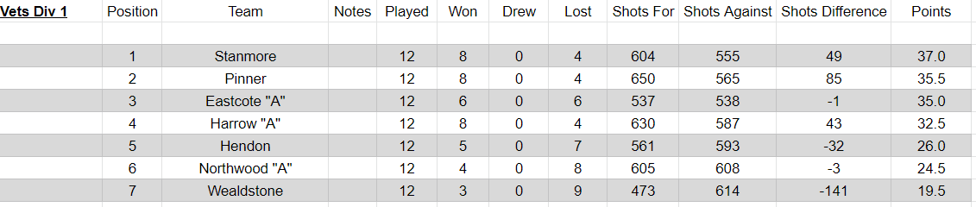

With one game to play, and that a home tie against our 2 out of the three games rivals, Stanmore, we needed a 4 to 1 win to clinch Division 1 on points difference.

Not to be! Although we won the tie by an aggregate 58 to 45 poinys, we narrowly dropped two of the three games by the narrowest of margins. We scored 3 match points; Stanmore took 2.

So near and yet so far! Or Ne Simus Brevis as our Club founders were wont to say.

We did had a very interesting last end on our rink. Although we were trailing quite badly throughout most of the game, we were holding 7 shots when their skip came up to play his last wood. There was a possibility that if he played his wood, he would promote one of ours, possibly giving us an unlikely victory (and the Championship). Fortunately for them, they spotted the state of the aggregate score and discretion was the better part of valour and he played a safe shot. To be fair, we would have done the same.

Note: The vets. is a Harrow and District League for over-60’s men, although limited numbers of ladies may play. Teams comprise 3 * triples and points are awarded 1 per game and 2 on aggregate. (5 pts max)

A couple of peculiar things always strike me about the vets. The competition is for us oldies. Minimum age 60, but average probably at least a decade more. We always seem to play straight through 18 ends pus trials without the usual break after 9 ends. It can be quite wearing, especially in the very hot weather; or come to that on rain drenched heavy greens,

The other oddity is that Pinner charges £2 “tea money” home and away. We never, ever have tea! In fact, we almost always have to pay for at least a couple of beers. Can we just call the £2 “match fees”?

Bidgood Leagues

We enter two teams in the Bidgood, one in Division 1, the other in Div 2.

This year our “A” team managed not a single match win. Played 8, lost 8 (although we did mange to take 5 individual games).

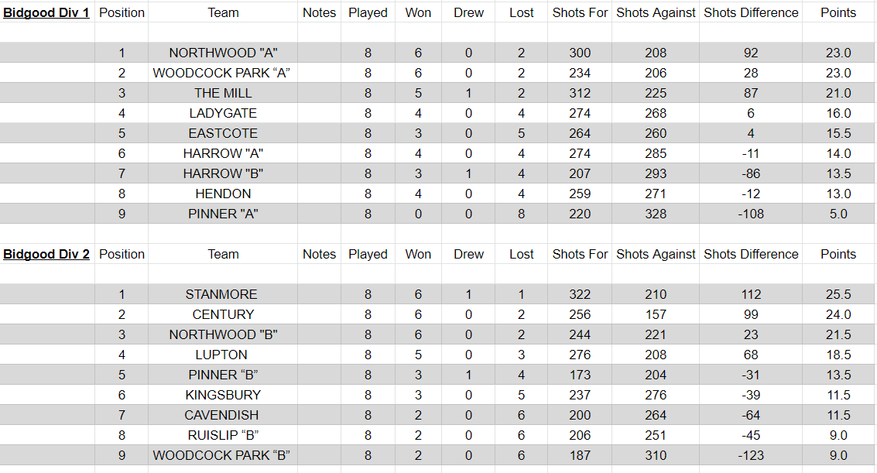

Our “B” team, otherwise known as Pinner Memorial, made a dramatic improvement from last year and managed a creditable 5th place.

Note: Match comprises 2 triples each side, mainly men (limited ladies) and play usually commences 1800 hours. Intended for players who work during normal day hours. Tends to be very competitive.

Some discussion about whether to field two teams next season. Any volunteers to take on one of the teams?

Lady Players

Until recently, lady players were not allowed to play in the Vets and Bidgood leagues.

I understand that this was because the organisers were worried that players could be upset by the bad language.

However, it was eventually decided that the men would just have to get used to it!

Fish & Chip Supper Drive
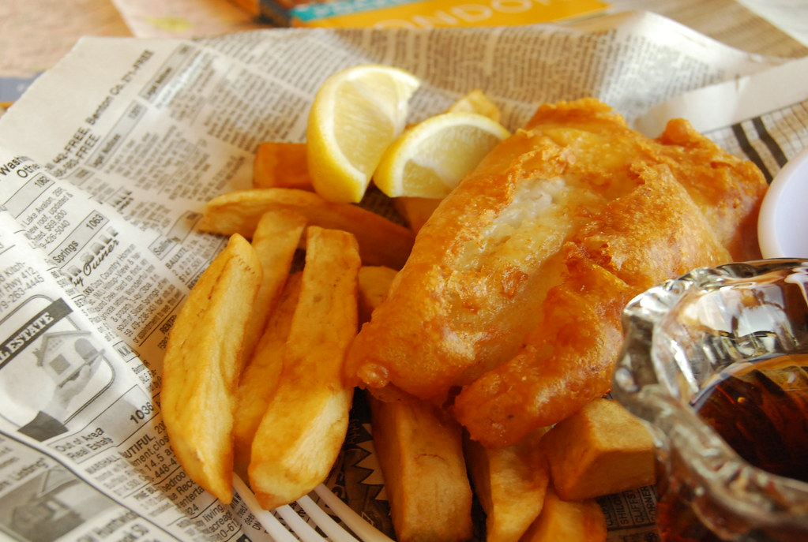
This Photo by Unknown Author is licensed under CC BY

25th August;

Well attended with almost 40 folk. A good night was had by all.

More, please!

Annual Dinner Was originally scheduled for Wednesday, 10th November, Grimsdyke Golf Club. Because of Covid problems and general lack of support, it has been cancelled, although I understand the same venue has been provisionally booked for next year. The internal cups and trophies were presented on the actual finals weekend September 11th and 12th.

It is hoped that a report will be printed in a later issue.

A message from President Rob Atack

Last drive and presentation Monday 27th Sept


There will be an end of season drive plus buffet and presentation to both the Coronation and the Vets first division runners up teams.
This Photo by Unknown Author is licensed under CC BY-NC
Bowling starting at 2.30, please arrive by 2 o'clock.
All food will be provided.
Please let me know if you are going to attend, this will help me with catering.

The 100-club draw will take place, top prize £100.
We will also have a raffle, any donation of prizes will be gratefully received

David Scott Drawn Pairs. Sat 24th July.

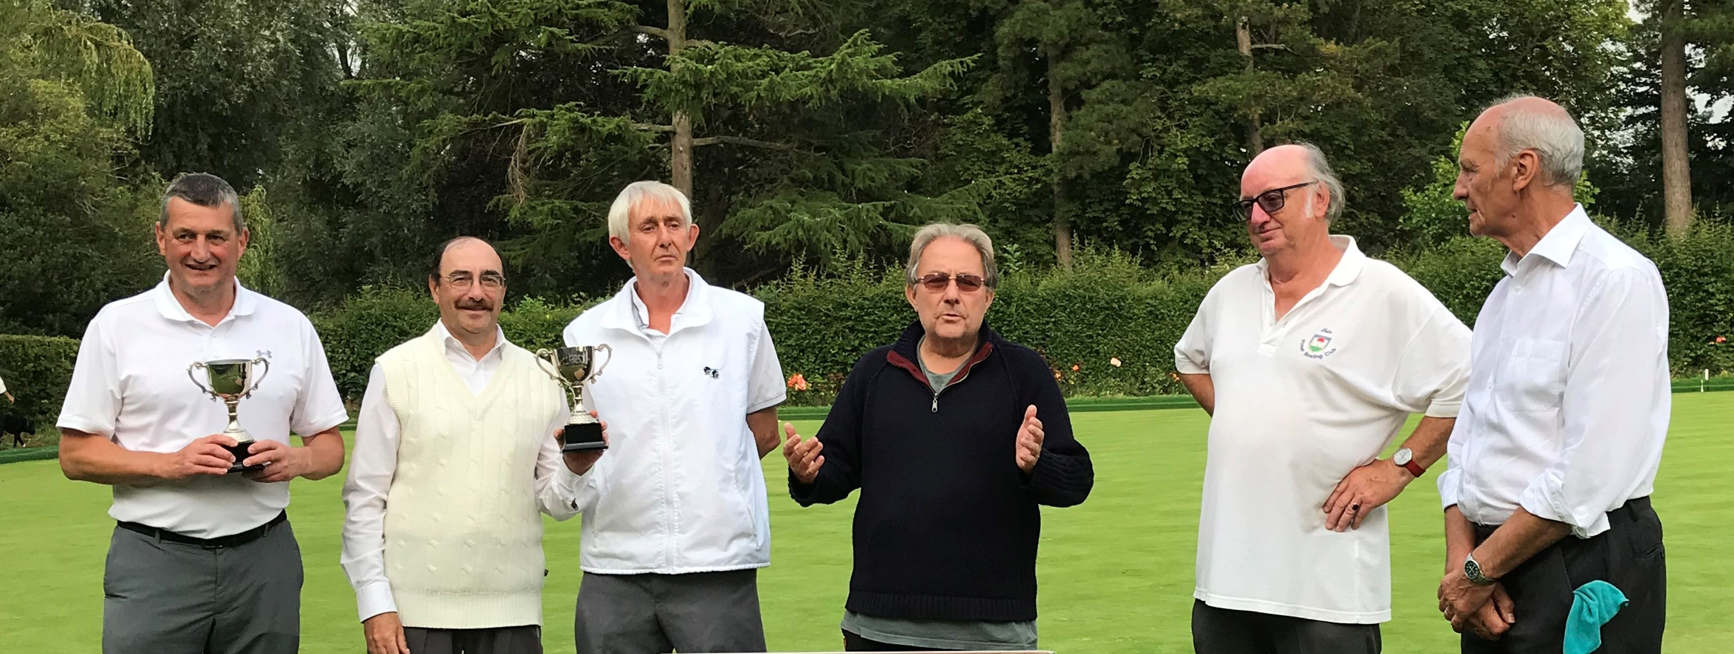
A fair turnout of 18 folk, although Colin the organizer had to make up the numbers to a round 18. The players played 4 sets of 6 ends, the best two pairs contesting a final of another 6 ends.
The winners were Anthony M and Steve B. Runners up were Colin J and John Crosbie. An honorable mention must go to Lorraine Welch who in her first main club competition missed the finals by mere points difference. I blame her partner who shall remain nameless. (me)!

And finally

All this talk about club badges reminds me of our dress code of not so long ago.
At the time our Club Captain was a bit of a Tarter. And of course he just had to clash with one of our more rebellious younger players who liked to dress a bit casual. Nothing too flash, you understand, and he duly wore a blazer and grey flannels, but tended to go tieless!
That would never do for the captain. When the trouble maker turned up at an important away match with an open necked shirt, the captain had a minor fit. “Put a tie on or go home!” was the command.
Well our rebel went back to his car for a root around but no tie could be found. Until suddenly he spotted a pair of jump leads in his boot. H’mn, not too dissimilar to the boot string ties favoured by Country and Western singers and indeed by the Teddy Boys of that era.
He duly put the black lead around his neck and re-presented himself . After some deliberation the captain, “Well that will have to do, but don’t you go starting anything!”
End

All contributions gratefully received.

Mike Jones michael.k.jones@btinternet.com

