Pinner Bowls Magazine

Issue 34 – May 2021

Home and Gardens Edition

1: New Season

I had rather hoped this edition would be all about the exciting opening drives and matches of the new season. But of course, the perpetual Covid and the current inclement weather has put paid to all of that.

Like the Anglo-Saxon fields of distant history lessons, our green has lain fallow for nigh-on two years and although the green itself has been kept in some sort of trim, the surrounds have been sprouting with gay abandon.

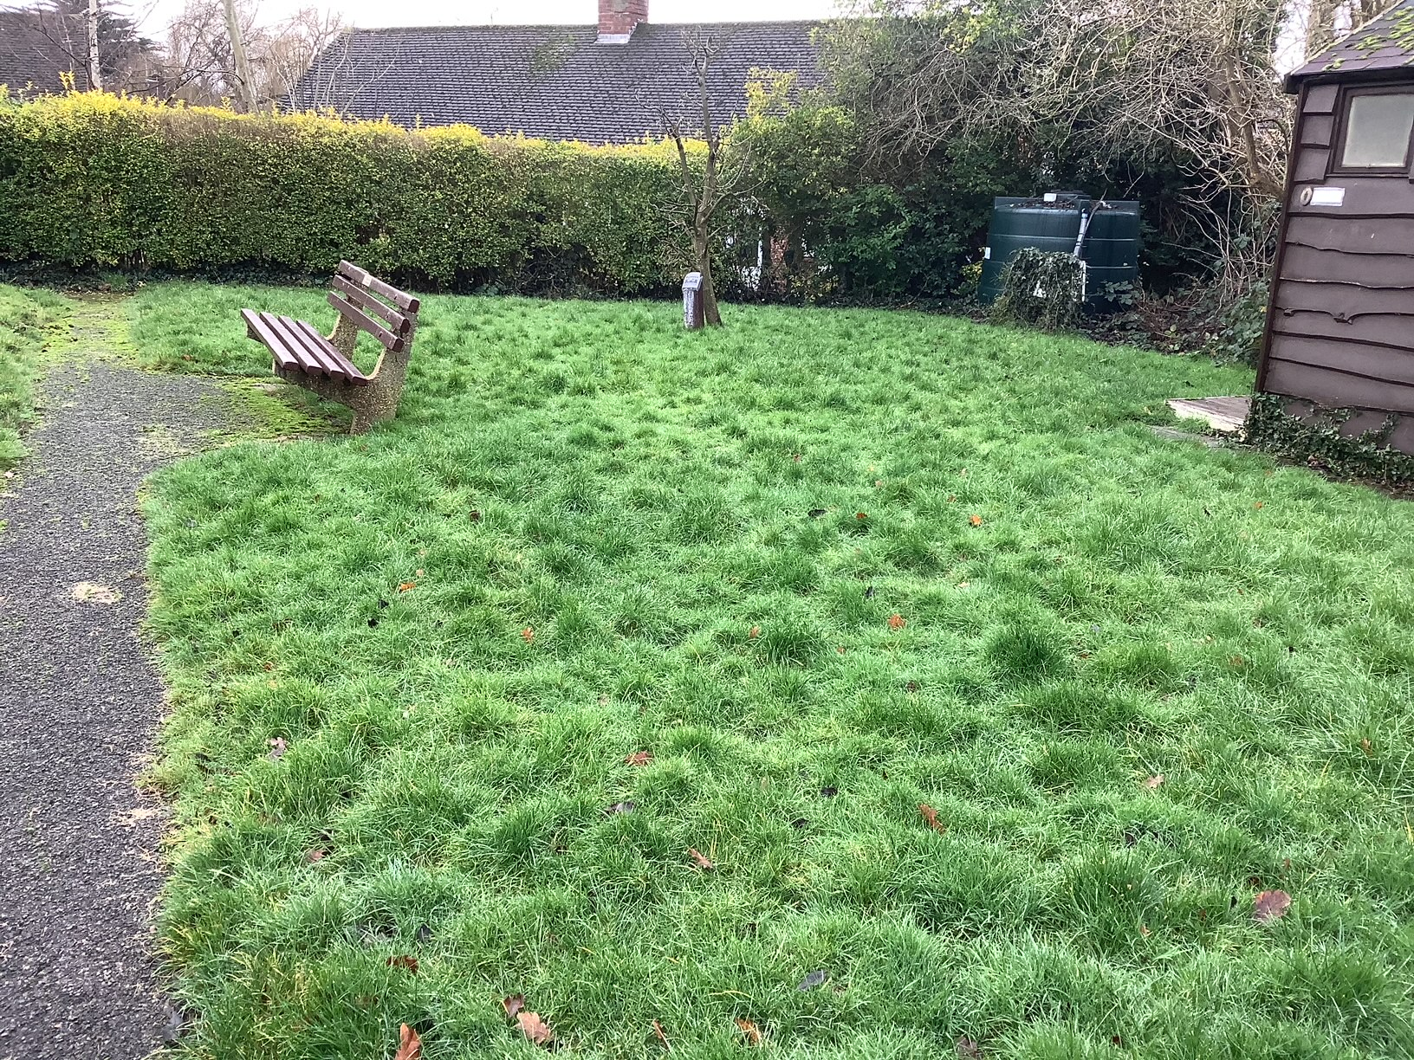

It looks almost as bad as some folks’ haircuts. But wait; all is not lost! To the rescue come the intrepid band of helpers organised by John Crosby, our new Maintenance man. Abetted of course by the usual suspects and a large band of helpers. I shall not embarrass them by listing names, but you all know who. Here is a snap of some of them in a 2-metre pole socially distanced working party.

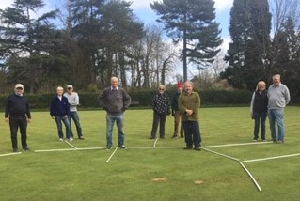

After many, many hours work, the green and grounds are now pristine.

And here is the “after” photo. Please wipe your feet before going on the green!

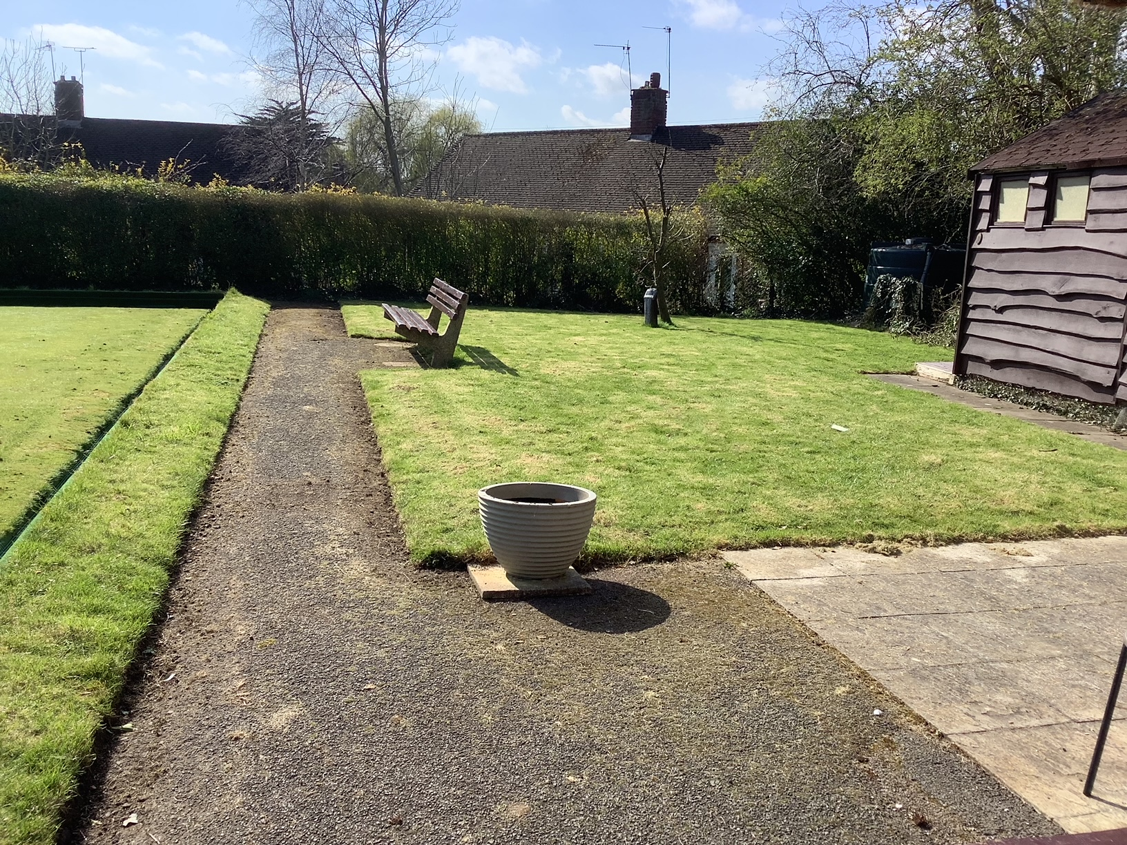

Now not being content with the exterior, the workaholics decided to have a crack indoors. The carpets have been deep cleaned, the toilets refurbished, (new porcelain in the ladies), the kitchen given a good scrub and finally, the whole interior has been re-decorated. As late as the afternoon before the opening drive, the interior looked like a building site and a lot of last-minute effort went into a massive tidy-up. Really well done to everyone involved.

Obituaries

It is near two years since we last played and some members are no longer with us.

We pay our respects to:

Joan Etherden; A long time member and an active player and helper, wife of Don Etherden our ex-chief coach.

Bill Richens; A keen player who was also President of the United Services Club with whom we have strong ties. Bill facilitated many joint ventures, including the annual bowls match Pinner versus United Services. The match at Pinner Bowls; the after drinks at the United Services.

Bryan Taylor; Bryan was an active member and until ill health intervened, used to run the Monday Aggregate and along with his wife Joan, organized Bridge evenings and Whist drives.

We will miss them all. RIP

Opening Drive – Saturday 24th April

Well, “Drive” was perhaps not quite the right word. Strictly, a drive comprises several teams playing several other teams in a “round robin” or “snake” format, usually three or more sets of 6 ends.

Still, who is counting? It was simply a joy to get out on the green and cast a few woods.

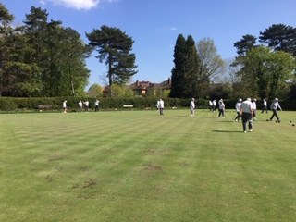

25 players turned up and the organisers arranged a draw for skips, then two’s and leads. We were then allocated rinks and told to “get on with it” although nobody seemed quite sure as to how many ends we played, nor even if we were to have trial ends. (Bit of a disadvantage for those of us who had not played for two years)!

I cannot report the overall results as there were none officially recorded; each rink just played until they were ready for drinks. Some played a mere 14 ends, others managed the full 18. We were last off with 17 ends before the leads rebelled.

I would like to report that the rinks were brilliant, but I’m afraid that would be egging the pudding a little. The dreaded Rink 4 lived up to its reputation and it did not help that I had packed the wrong woods. My indoor AERO Defiance, the least curving woods permitted by world Bowls. I do not exaggerate when I tell you that the woods curved against the bias UP the hill on Rink 4! My woods were certainly socially distanced from the jack.

But never mind. It was President Rob’s birthday and he treated us all to a bevy or two. You would never think he is now almost old enough to play in the “Vets”!



Club Strip Official club shirts are available from Evelyn and John Grafton.

White Polo Tops embroidered with the
Pinner Club logo and your name
are available to order through
Evelyn & John Grafton

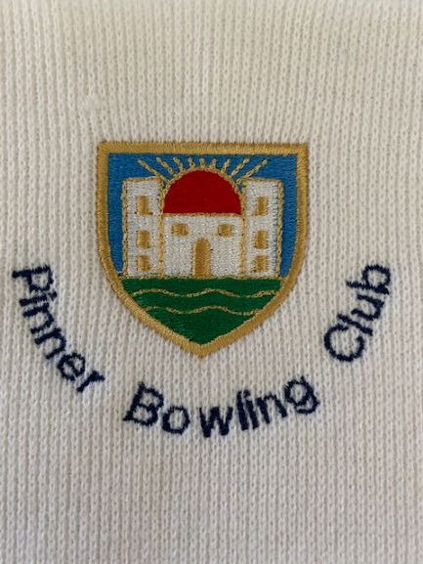

We have a selection of samples members can try for size which we recommend as these tops will be non-returnable.
Cost = £22.50 approximately
This price could vary depending on the numbers ordered.

Contact:- Evelyn 07973 745265

The Council Cough up £84 Grand!

No, not Harrow Council. Ladygate Bowls Club had a bit of a catastrophe when their roof was severely damaged during a storm. £84,000 to repair!

No problem, good old Hillingdon Council came up with the loot.

What a contrast with other local authorities we could name.

Veteran’s Matches Pinner are once again entering a team in the Harrow & District Veterans League. The league is for players who are aged 60 or over and a limited number of lady players are permitted. Matches are normally played in the afternoons mid-week. Gary Welch is the team captain and organizer.

Bidgood Matches Harrow and District League originally for men, but ladies now take part. The league was set-up for players who worked normal hours and hence matches usually start at around 6:pm. Pinner enter two teams. Pinner A captained by Richard Segalov and Pinner Memorial Park (Pinner B) captained by Rob Atack.

Both the Vets and the Bidgood results will be posted in this magazine.

Inter-Club Matches Pinner play a number of friendly matches against nearby clubs, usually on a home and away basis.



The matches for the entire season are listed on the club fixtures card; nearer the time, usually a week or so, the fixtures are put on the clubhouse notice board and members are invited to put their names down for possible selection.

The selection sub-committee will then pin up the teams in good time.

A book of maps and directions for away venues is held in the clubhouse.

I should stress that these matches are mainly social and players of all standards are encouraged to put their names up for selection. You have a very good chance of selection for a reasonable number of matches.

Membership

After a rather grim year of almost complete lock-down for a couple of seasons, we have lost around 10 playing members and half a dozen social. Not perhaps as bad as it could have been and it probably helped that the committee waived membership fees for this year – for players who had paid last year. Also thanks to Hon Sec and our coaches who managed to entice a few potential members who are now under coaching.

Nevertheless, our full membership in the not too olden times was around 100! It’s probably unrealistic to expect this nowadays, but we could definitely use a few extra.

Ways and means are being considered and hopefully will be discussed once full committee meetings resume. But until the season gets going properly, it’s going to be difficult.

Bowls England are suggesting a nationwide Bowls “Open Day” over the May Bank Holiday; but unfortunately we will still be under at least partial lockdown. Perhaps if the weather breaks, we could re-consider.

Pinner Day is another possibility, but again the virus has intervened. The Pinner Show has been moved to autumn and of course, by Murphy’s Law now clashes with our Finals Weekend. We may be able to put a banner up and at least gather a few names for the following season.

We shall of course try to organise some non-clashing dates for our own Open Days; tba.

In the meantime, if anyone knows of potential friends or neighbours who may be interested, do get them to come along for an informal roll-up.

Future Events As you are aware, things are a little up in the air right now, pending clarification of the virus precautions and the unseasonal weather.

Some events that are expected or planned are:

Friday 14th May: Friendship Cup versus Harrow, an annual match against our old friends often featuring a full meal or at least a buffet and drinks. 5 mixed triples at home. Please watch the notice board

Saturday, 15th May: Open Day. It’s not clear if this is to go ahead yet and will depend upon weather and committee decision. Please watch the notice board and keep an eye out for the Hon, Secretary’s e-mails.

14:30 hours, Wednesday 9th June: Club Wednesday. Due to commence. The club day will be a weekly affair organized by Gary W.

Monday Roll-Ups. Start date yet to be finalized and pretty much weather dependent. May have a regular start time, or may be ad hoc possibly using the Facebook What’s App messaging service. To be decided; Watch the notice board and/or messages from Hon. Sec.

Social Events: To date, none are planned or at least diaried. Should anyone have any ideas that they are prepared to help organize & run, please contact the committee.

Past events have included:

Military Whist Drives

Bridge Evenings

Games Evenings (Dominoes, Darts, Shuffle Board etc.)

Games Days (Open Air, Bowls Themed, but also other lawn sports)

Fish Supper; Bowls Match followed by Fish & Chips.

Bingo

Petanque

Quizzes

If you are prepared to have a go, you will find enthusiastic helpers are always prepared to help on the night.

Friday Abbreviated Game for the Old and Weary?

Yep that’s me. Not yet quite ready for the “Niners”, but I’m starting to find heaving three or four woods for 18/21 ends sometimes a little tedious on a very damp or a very hot day.

I’ve been toying with the idea of running some sort of abbreviated session on Friday afternoons. Probably playing something like 12 ends with 2 woods per player. (With 2 woods you can make up many permutations of odd numbers of players). Perhaps rotating skips, two’s and leads every four or six ends so everyone gets a crack at different positions). And if after 12 ends, some wanted to finish and some wanted to carry on, then fine.

Anyone interested, please let me know. If it flies, I would expect to set-up a rota to organise each Friday.

And Finally During the recent forced closure of the green, there were rumours of unsavoury characters squatting on the premises. Here is an image captured by our surveillance.

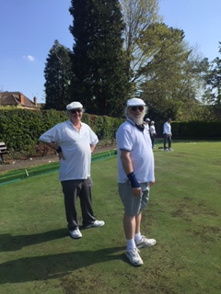

Does anyone recognize them?

Enjoy your bowls,

Mike Jones

Any copy, please to:

michael.k.jones@btinternet.com

